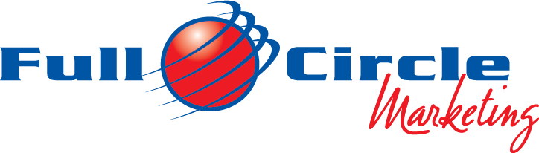
Internships at Full Circle Marketing

We are currently accepting applications for Spring, Summer, and Fall Internships.

Full Circle Marketing welcomes interns who are ready to gain experience and knowledge in a fast-paced environment. Interns must be organized and able to manage the high-speed demands in the office by creating tasks lists & follow up & through. Projects include; Shenandoah Apple Blossom Festival, Old Town Winchester, Top of Virginia Building Association and other clients. Candidates must be quick learners, multitask oriented, attentive to details, take initiative, be ready to have fun and work diligently in a small relaxed office environment in Old Town Winchester. The intern will be working directly with the owner 65% of the time. The atmosphere is like the dress code – business casual, upbeat, fun learning environment.

Full Circle Marketing handles: Marketing, Advertising, Public Relations, Promotional Campaigns, Event Operations, and Sponsorship Development/Sales.

Requirements and Tasks:
- Good oral and written communications skills. Computer skills (PC, MS Office, and Basic Web-site knowledge/social media, Adobe Illustrator, Canva, Publisher, Constant Contact Email blast) and clerical duties; email and data Excel.
- Assist in developing advertising, marketing and promotional campaigns along with managing, promoting and developing new ideas for current and new events.
- Write press releases, radio and TV copy, E-Blast, utilize Facebook, LinkedIn, and Instagram.
- Set up meetings with community stakeholders; assist in developing sponsorship programs.
- Contact various media outlets for publicity and trades.
- Identify and develop new revenue streams.
- Assist in day of event operations, ticketing, vendor relations, tear down.
- Promote and market the company via; University Alumni, Chamber, Rotary, other networking opportunities.
- Assist with all projects efforts (PR, media campaign, sponsorships).

This internship position with Full Circle Marketing will provide a vast amount of practical hands-on experience with various events and tasks. It will allow you to use the knowledge gained and apply it in your work place. Full Circle Marketing will also assist the person (provided person has completed a satisfactory work record) in finding future employment upon taking their skills to the next level, using business contacts and resources available within the industry.

To apply, e-mail a cover letter and resume to Dario Savarese, dario@fullcirclem.com

